Time Table Management System

Use Case Model Document

Version 1.0

i16-0127 Furqan Hameed Section E

i16-0037 Moiz Adnan Section E

i16-0109 Muhammad Shoaib Manzoor Section E

Revision History

|  |  |  |  |
| --- | --- | --- | --- |
| **Date** | **Version** | **Description** | **Author** |
| 6/10/2018 | 1.0 | Added document format, headings and system features. | Shoaib Manzoor |
|  |  |  |  |

Table of Contents

1. System Features 4

1.1 Smart Time Table Generation 4

1.2 Time Table Presentation Views 4

1.2.1 System Administrator View 4

1.2.2 Student View 4

1.2.3 Professor View 4

1.3 Professors Managing Classes 4

1.4 Student Specific Views 4

1.5 Manage Time Tables 4

2. Use Case Diagram 5

3. High-Level Use Cases 6

4. Use Case Ranking 6

5. Fully Dressed Use Cases 6

System Features

## Smart Time Table Generation

Allows for the automatic creation of weekly schedules which satisfy classroom constraints, professor preferences and ensure minimum student clashes. Time Table Management System uses the school/ university’s existing dataset to extract required constraints and constructs an optimal time table.

## Time Table Presentation Views

The system presents a schedule in many different views for each actor involved. Students and Professors can view classes relevant to them allowing for a much more concise and easy to understand view. Special features are also available based on the current view being presented (e.g. modification for administrators, reschedule/ cancel operations for professors etc.)

* **1.2.1 System Administrator View**

Allows academic officers to log into the view and carry out important tasks such as generating a new time tables, adjusting class schedules and tweaking classroom constraints to suite the current requirements.

* **1.2.2 Student View**

Allows students to enter their respective batch and section to view a comprehensive time table including any notifications left by the administrator or professor to highlight changes made in the schedule.

* **1.2.3 Professor View**

Allows professors to log in and view their assigned schedule. Professors can also cancel any assigned class in case of emergency and request administrators to reschedule a class as per their preferences.

## Professors Managing Classes

The system allows for professors to cancel their classes or request to reschedule their classroom to any available slot based on their preferences.

## Student Specific Views

The system allows for students with non-conventional course registration to be assigned a special view where they can log in and view schedules specific to them instead of browsing multiple batches and/ or sections.

## Manage Time Tables

The system allows for the modification and adjustment of existing schedules based on new dynamic conditions that have arisen. Academic Officers can easily view possible available slots and appoint a new class accordingly. Schedules may also be modified based on other criteria. (e.g. upcoming national holidays, classroom repair work, lecturer unavailability etc.)

# Use Case Diagram



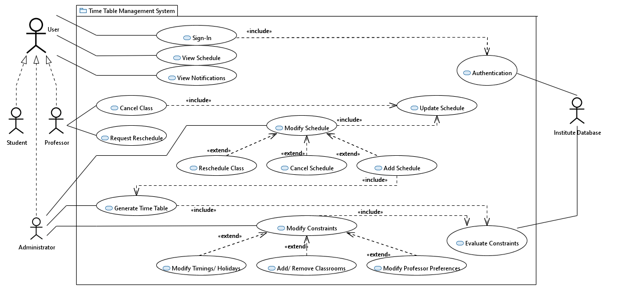

# High Level Use CaseUse Case Ranking

# Fully Dressed Use Case